Instructions for importing a save sender file into Outlook

- With Outlook open, select the Actions off the Menu bar.
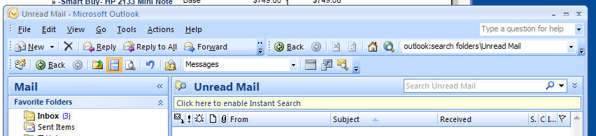

- Next select Junk E-mail >Junk E-mail Options from the menu.
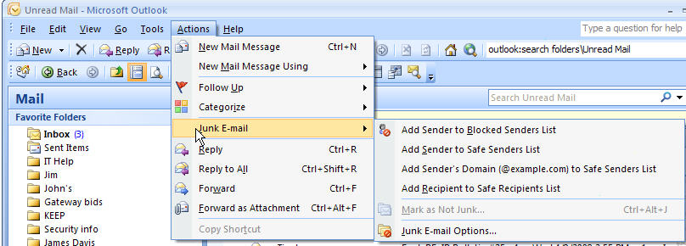

- There will be several tabs across the top of the Junk E-mail Options screen, click on the Safe Senders tab.
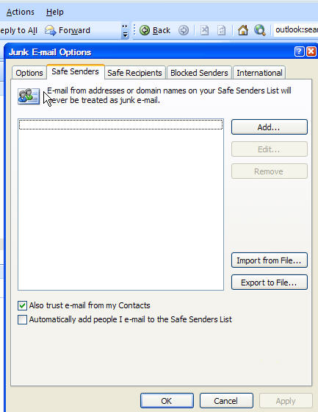

- Click once on the Import from File… button, this will open up a window where the import file can be located. Click on the My Computer icon located on the left side of the opened window. Double click on the P: drive and open the directory called Outlook Export; double click on the file and it will add the information into your Safe Senders address book. This should include the following entries @nr.edu and @vccs.edu. (Some users may have other addresses already in this list.) Click on the OK to complete the process.

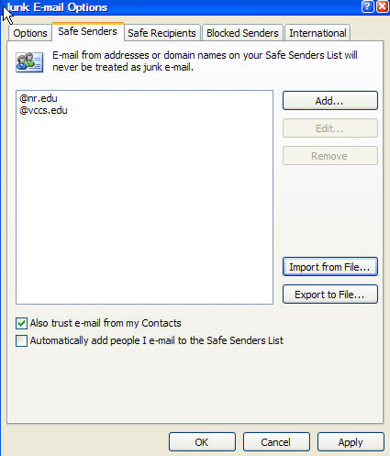

- If you have any problems with this please contact nr4help@nr.edu or call (540) 674-3621 .

